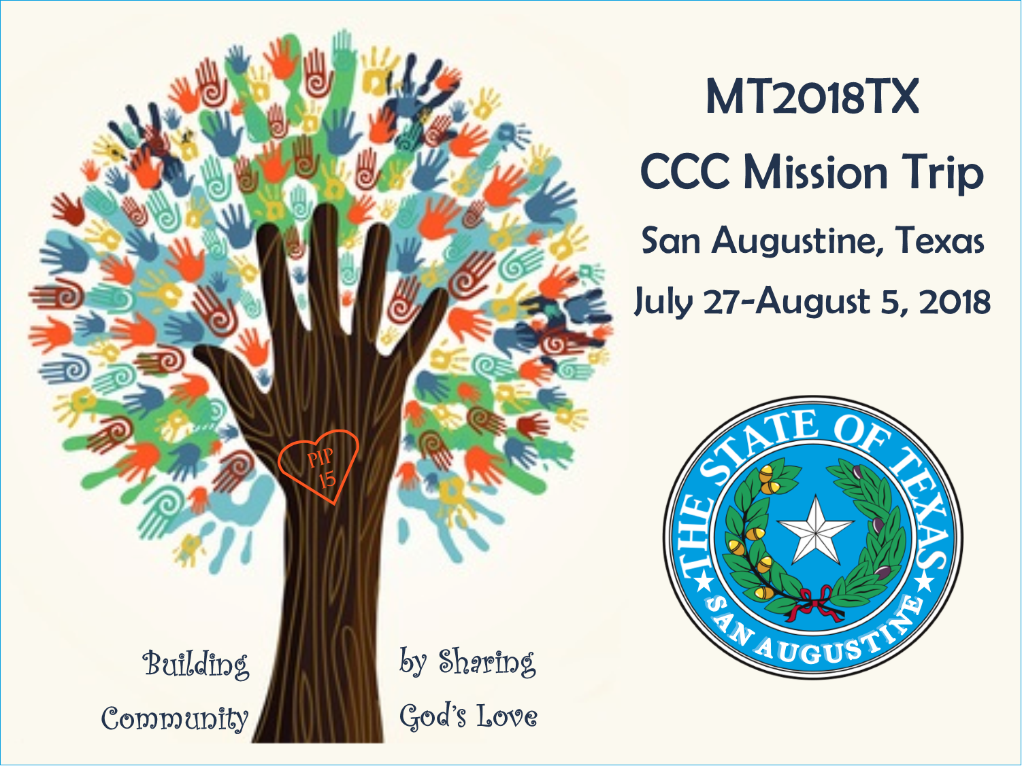

Dear {INSERT NAME OF ADDRESSEE},

I am heading to Texas this summer, with our church, Community Christian Church of Lincolnshire! Together with the Youth Group and Youth Leaders, we will work in this flood ravaged region through a program called Next Step Ministries. We will be God’s hands and feet to the residents who live in San Augustine for our week-long mission.

We have done some fundraising toward our trip through events at our church, however we are still in need of funds to help with the expenses. I am reaching out to family and friends asking for your support. Would you be willing to be sponsor me this year by sending a donation? If you could, I would greatly appreciate it. Any size donation is helpful and would be a blessing.

Donations can be made directly to our Church:
Community Christian Church (with Mission Trip/{INSERT YOUR NAME} in the memo line)
1970 Riverwoods Road | Lincolnshire, IL 60069
Please complete and include the attached support form.

During the trip, we try to send out updates with pictures for our supporters, so that you can see what great work we will do with your help! If you would like to receive these emails, please include an e-mail address when submitting your donation so that we can share our experience with you.
Thank you so much for your consideration!

God Bless You!

{INSERT YOUR NAME & SIGN}
For more about the trip, visit the web page: http://www.ccclincolnshire.org/cccs-2018-mission-trip

Please hold us close in prayer as we prepare, travel, serve and grow together in God’s love. Pray that we can strive to be likeminded, having the same love, being of one accord and of one mind along with those we help and - just as Jesus always did. Pray for our safety and that we may and spread our joy and kind spirit with the many we will serve.

Yes! I would like to support the 2018 CCC Youth Mission Trip to San Augustine, Texas!

Supporting Donation amount $__________
I would like to support the following attendee(s) {INSERT YOUR NAME}

My name: _________________________

My address: _______________________ _______________________________

My email: ________________________

Please mail this completed form along with your check in the enclosed envelope to:

Community Christian Church
1970 Riverwoods Road
Lincolnshire, IL 60069

Please write checks payable to Community Christian Church
with “Mission Trip + {INSERT YOUR NAME}” in the memo line

THANK YOU VERY MUCH!!

